ART for SELF-EXPRESSION

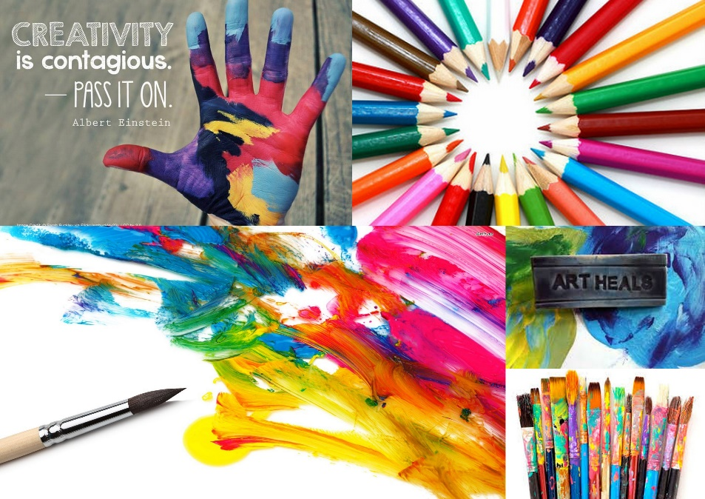
Art Therapy Workshops

Join us in a small group setting as we explore the creative process as a means for self-expression, spontaneity, connection, and fun.
Saturday, May 14th
10:00-12:30 & 2:00-4:30

Facilitator:

Laura Andrew is a professional Art Therapist from Canada. An artist and traveler, Laura is a former Taiwan resident and a Mandarin speaker. Passionate about the creative process, Laura believes that the practice of art making is healing and life-enhancing.

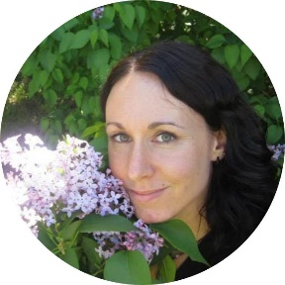
“Every child is an artist.” ~Picasso

